Robot V 1.28

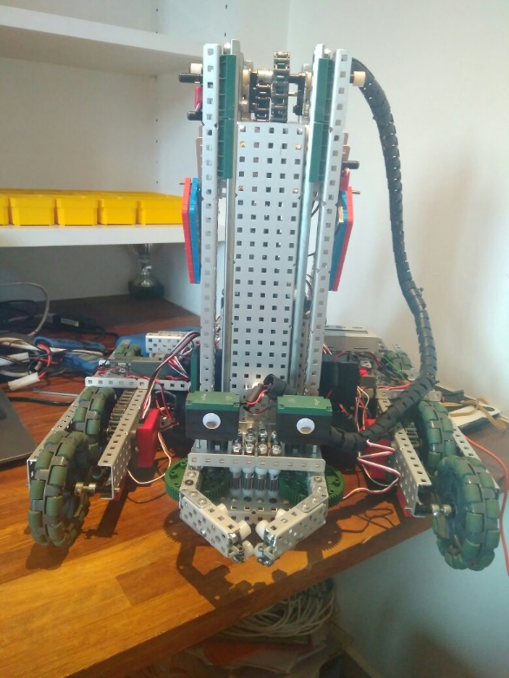

SPECIFICATIONS:

* 6 Motor HS drive
* Two drive chains
* 6 wheels
* Aluminium structure
* 4 motor lift
* Three stage lift
* 2 motor claw

DIMENTIONS:

17.5” * 15” * 17.5 when not extended

**What needs to be changed:**

* Add mobile goal manipulator element to claw
* Add PID

By Robbie Buxton

02/8/2017 – 11:54

**Overview:**

For this version of the robot we managed to fix two problems with one change. The first problem was that the robot unstable and was very prone to falling over. The second problem is that we realised is that we think that if robot tries to go over the bar into the 10 point zone the bottom of the lift will get caught on the bar and will result in it getting stuck. We think we fixed both these problems by moving the front wheels into the centre of the robot and added a new pair of free-wheeling wheels at the very front to increase the size of the base of the robot therefore increasing stability. By moving the wheels to the centre when the robot passes over the bar the wheels should also be touching bar instead of the lift stopping it getting stuck. We have not been able to test this however because our field elements still have not arrived.

**WHAT HAS BEEN CHANGED:**

* Added extra pair of wheels for stability
* Moved front wheels to the middle